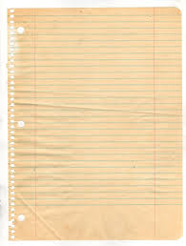

I

the

a

play

like

can



see

go

she



is

it

he





brown

black

blue

red

white

yellow



three

two

one



four



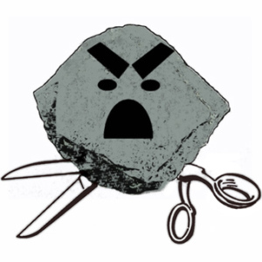

Rock Paper Scissors

Dolch Word Game



you

to

in

on

out

be





run

yes

no



will

my

me







little

and

big



look

down

we

at

am

up