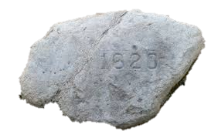

I

the

a

play

like

can



see

go

she



is

it

he





brown

blue

black

white

yellow

red



three

two

one



four



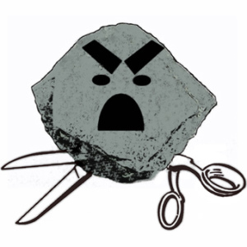

Rock Paper Scissors

Dolch Word Game

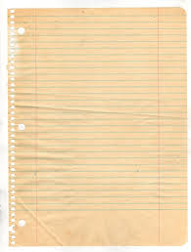

to



you

to

in

on

out

be



run

yes

no



will

my

me





little

and

big

look

down

we

at

am

up

